1. 问题描述：升级EKS和组件Ingress Nginx，一部分请求会报502错误。客户提了Support Ticket，但是Support无法针对开源组件Ingress Nginx给予排错。
2. Actions：通过组合请求，直接请求后端Pod，确认没有问题。查看Nginx日志，发现出现两个Transfer-Encoding: Chunked的请求会报502错误。

2023/06/07 03:27:08 [error] 25#25: \*30011 upstream sent duplicate header line: "Transfer-Encoding: chunked", previous value: "transfer-encoding: chunked" while reading response header from upstream, client: 200.168.217.174, server: api.yj2025.com, request: "POST /storehouse-pc/v1/stock/list HTTP/1.1", upstream: "http://200.168.159.14:8088/storehouse-pc/v1/stock/list", host: "api.yj2025.com", referrer: "https://yj2025.com/"

1. 找到了一篇文章，说明了类似问题是由duplicate "transfer-encoding: chunked"导致。

https://github.com/istio/istio/issues/24753

1. 按照如上思路，发现Nginx Plus 28版本就会拒绝duplicate "transfer-encoding: chunked"，而客户升级Ingress Nginx后，Nginx Plus版本是29。

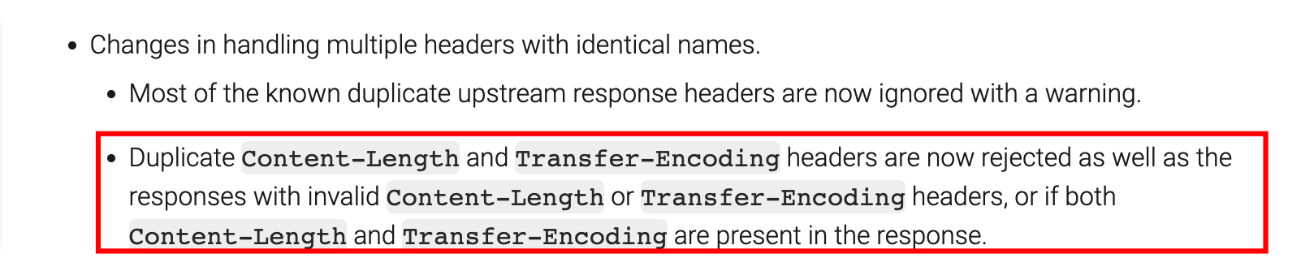

Reference: <https://docs.nginx.com/nginx/releases/>

1. 解决思路：建议客户先用低版本Ingress Nginx进行测试，待测试无误后进行域名指向迁移。